2022 AIA/CES Conference Session Participation Form (C-1)  - Sessions listed on this form have been registered with the AIA/CES Records. Attendance will be recorded on your behalf by the CES Registered Provider. You may request a copy of this form for your files.  - You must include your AIA membership number to get credit. Check Yes for those activities you have completed.  - Member numbers that are missing or not legible will not be awarded credit.  - Partial credit/concurrent sessions marked “attended” are not awarded. Attendance is subject to verification.  - DO NOT SEND THIS FORM DIRECTLY TO CES RECORDS — RETURN TO CONFERENCE STAFF!  - Conference Provider will verify your attendance before forwarding this form to CES Records to record credit. | 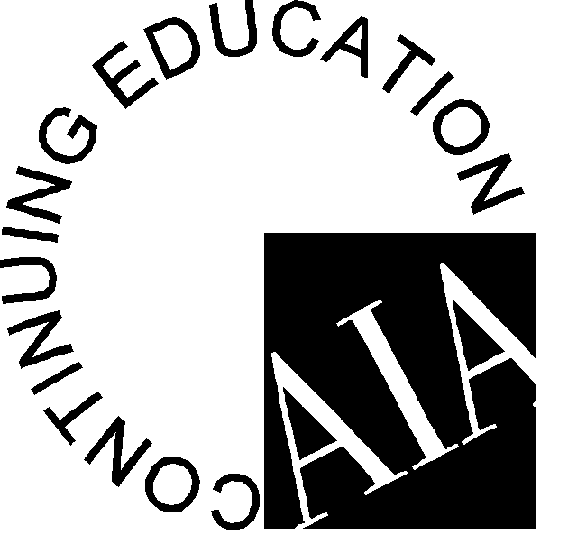

Participant Name:
AIA Member #: ________________________________
Request Certificate: Yes_____ No_____

Provider Name: Association for Learning Environments

Conference Number: 2022 June Symposium

Provider Number: F118 Program Dates: June 21-22, 2022 Program Location: Washington, DC

Attended | Session # | Program Title | Credits | LU | LU/  HSW
June 21, 2022 – Presentation 1 – 1:30 PM

Yes No | 2022JUNSYMP01 | Enhancing Student Success Through Integrated Student Support | 2 | Yes
June 21, 2022 – Presentation and School Tour – 4:00 PM

Yes No | 2022JUNSYMP02 | Healthy Buildings to Facilitate Student Performance and Net Zero, WELL Certified School – John Lewis Elementary School | 1.5 |  | Yes
June 22, 2022 – Presentation 2 – 8:30 AM

Yes No | VASE2206/LS2154 | Conversations on Schools that Heal | 2 |  | Yes
June 22, 2022 – Presentation 3 – 10:30 AM

Yes No | 2022NTX23MAR | Panel Discussions | 1 | Yes
June 22, 2022 – Presentation 4 – 11:45 AM

Yes No | 2022JUNSYMP03 | School Facility Leadership During Tumultuous Times | 1 |  | Yes
 |  | Total Hours Attended:
I hereby certify that the above information is true and accurate to the best of my knowledge and that I have complied with the AIA Continuing Education Guidelines for the reported activities.

ATTENDEE SIGNATURE (Credit will not be awarded without signature.) DATE

Participants: Complete and return this form to: The registration desk, or send to:

Attn. Edi Francesconi – A4LE – 11445 E Via Linda, Suite 2-440 – Scottsdale, AZ 85259 – E-mail: edi@a4le.org

