A4LE Rocky Mountain Chapter 2021 Call for Entries
As a leader in the field of educational facilities planning in the A4LE Rocky Mountain Chapter Area, you are invited to participate in the annual A4LE Rocky Mountain Chapter Awards Program of School Planning, Architecture and Individual Achievement.

2020 RMC A4LE Peak Award Winner

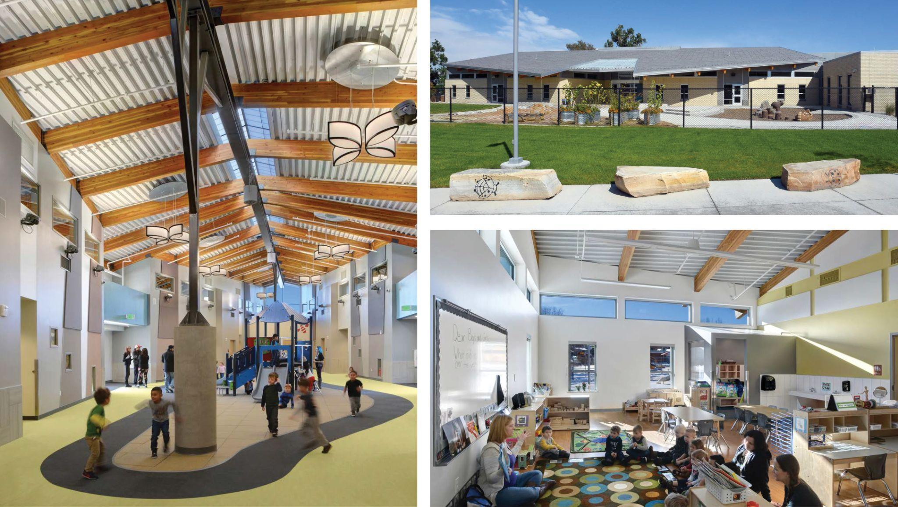

Early Childhood at Maddox, Englewood School District
RB+B Architects (Photo used with permission)

It is a great opportunity to share your best planning experience or design of educational facilities with the rest of the community. We are also requesting submittals on individuals who have committed their career to K-12 school planning and/or design. The award ceremony will take place in-person at the Chapter’s Annual Holiday Party. All projects will be prominently displayed as part of an exhibition during the party. All projects will be reviewed prior to the party by a selected Jury representing all sides of school planning, design and construction and evaluated within three categories: new construction, renovation and/or addition, and un-built projects.

Holiday Exhibition and Awards Party Location and Time:
Day/Time: Wednesday December 15, 2021 @ 5:30 pm
Location: TBD
*We understand that COVID-19 will play a part in the 2021 Holiday Party. The A4LE Awards Committee is hard at work planning a safe and fun experience for this year. Please be on the lookout for more information to come shortly!

Submittal Milestone Schedule:
- October Call for Entries
- November 12 Application and Fees due (online)
- November 24 All Awards Submittals due online via Google Drive
- December 15 Holiday Exhibition and Awards Party
5:30 PM Party starts, Awards Ceremony at 6:30 PM

The Jury
A distinguished panel of educational facility practitioners with expertise in education, planning and architecture will review all application materials.

A4LE Rocky Mountain Chapter Awards Categories
Multiple projects in each category may be recognized as an award winner. Each award-winner will be specially noted at the award ceremony, distinguished in the exhibition, and included in The Rocky Mountain Chapter Newsletter press release.

Design Awards
- Peak Design Award– new construction*
- Summit Design Award - renovations and/or additions**
- Rockies Design Award – projects not yet built or never to be built
*80% SF or more of new builds are considered new construction.
**79% SF or less of new builds are considered additions.

Planning Award
- Mountain and Plains Planning Award - Long Range planning for programs, campus master planning. (i.e. Educational Specs, or Bond Programs)

Planner of the Year
- Dr. William R. Maclay Award – The Chapter’s outstanding individual recognition for Service, Performance or Achievement in Planning

Criteria for Design and Planning Awards
Submit projects which have been built within the last 5 years. The jury considers how well the project satisfies its own design intent. The evaluation considers the written narrative and design response in the following four areas with the heaviest weight on the learning environment.

Planning Process: | Define and describe the process used in the planning of this facility including:  - Who was involved in the process?  - What was the structure of the planning process?  - How did the process affect the learning environment?  - How did the Planning Team continue to be involved through the design, construction, and post occupancy phases?  - What methods were used throughout the process to ensure the final environment would align with the Vision and Goals set during the planning process?
Learning Environment: | Describe how the learning environment:  - Reflects the desired learning program.  - Relates to the learner/user.  - Supports varied learning styles and instructional delivery methods.  - Enables all Learners to be successful.  - Addresses future changes in Educational approaches through flexibility and adaptability.
Physical Environment: | Describe the physical attributes of your learning environment and how it:  - Demonstrates sustainability.  - Supports safety and security.  - Demonstrates a creative use of materials, systems, and other building elements.  - Relates to the existing site and the greater environment.  - Inspires both internally and externally.
Community Environment: | Describe how your planning and design response:  - Engages the community, creating a sense of ownership.  - Takes advantage of the assets available within the community.  - Fosters community use/joint-use, partnerships.  - Reflects the unique attributes of the community.  - Connects students to their community and environment

2021 A4LE Awards Chair Contact:
Michael Clough
Wold Architects & Engineers
1553 Platte St, Denver, CO 80202
mclough@woldae.com

Submittal Requirements
- Each Design or Planning Project submission will include 1 folder of not more than 12 pages (format: 11x17 landscape layout, minimum font size: 11) of project information and photos.
- As you complete the required files, i.e. project data sheet, narrative, photos, etc., please save them to one electronic folder titled “2021 RMC Awards Data – Name of your project”.
- For 2021 submissions will only be accepted online via Google Drive.
- Upload your entire folder to the following link
- Sort your submissions into their respective category sub-folders (Peak Applications, Rockies Applications, etc.)
- Once your folder/s have been uploaded please notify the Awards Chair via email that the submission has been uploaded. In the same email, please include your filled out “Photography Release Form” with proper signature(s) (which can be downloaded here ).
- Descriptive data on the Project Data Sheet should include the following:
- Project name, location, and specific use
- The school’s design team – name of architect, educational planner, and any other appropriate credits
- Name of owner (school district and superintendent’s name, or institution and president’s name)
- Name of Contractor
- Project Delivery Method
- Occupancy date
- Project data – grades housed and pupil capacity
- Project size – site size, gross area, area per pupil, net or gross
- Project cost and cost per square foot – exclusive of land, landscaping, furniture, and professional fees
- File Size Guidelines – All Files Should be RGB
- 1 Main Exterior Photo File format .JPG or TIF, 300 dpi
- 1 Main Site Plan Diagram File format .JPG or TIF, 300 dpi
- Supporting Photo Files (Interior/Exterior) File format .JPG or TIF, 300 dpi
- Supporting Text Files/Graphics File format .pdf
- Provide one PDF with all images and File format .pdf
text combined, in addition to the files
listed above.
- 1 single 11x17 graphic page of File format .pdf 150-300 dpi
text + photos for the People’s Choice
Award slideshow (upload via this link )

Important! You must include the following files:
Project Data Sheet (PDF)
Project Narrative (PDF)
Supporting Photos, Site Plans, Graphics (.JPG or PDF)

*Please note that large files over 10MB (i.e. an Adobe Acrobat PDF file) may take a long time for jurors to download. It is suggested that you create smaller files for juror ease of use.

Design Panel specifications:
- Design Panels shall only be provided for the Awards Exhibition on the day of the Holiday Party.
- Firms are responsible for delivery and pick up of their panels.
- All entries must be exhibited on a maximum of (2) display panels. The two boards must contain at a minimum:
- Site plan
- Typical floor plan or a combination site plan/floor plan
- Narrative of 400 word maximum responding to the evaluation criteria
- All other images/architectural drawings included are at the discretion of the entrant
- Displays must be mounted on 20” x 20” foam board panels (Gatorfoam or other suitable, lightweight, warp-proof material) in order to be accommodated. Multiple-panel displays can be mounted either vertically or horizontally.
- All architectural drawings shall be shown legibly and accurately at scale, with numerical and graphic indication of scale.
- Please provide your own easels for display
- Projects in the design concept category shall include pertinent explanatory data to document the design concept.
- All projects in the renovation category must include both “before” and “after” photographs as well as “before” and “after” floor plans.
- Descriptive data on the panels should match the requirements for the Project Data Sheet described above.
- No materials are to be forwarded directly to the Jury.

2020 RMC A4LE Summit Award Winner
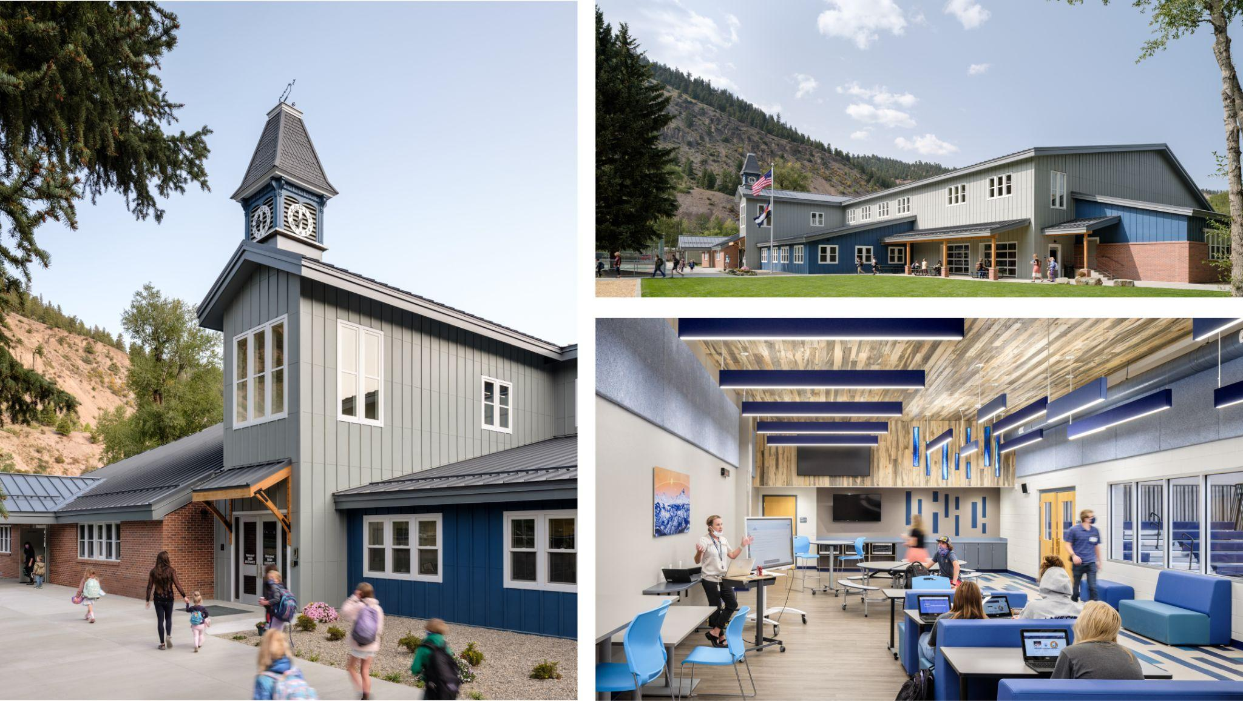
Lake City Community School, Hinsdale County School District RE-1
RTA (Photo used with permission)

Criteria Dr. William R. Maclay Planner of the Year Award
Candidate may self-nominate or be nominated.
Qualifications of Candidates:
- The candidate must be an A4LE member in good standing or an emeritus member.
- The candidate must have been actively engaged in one or more of the professional areas identified in the A4LE Bylaws as being essential to qualify for A4LE membership.
- The candidate must not have previously received the Chapter Planner of the Year Award.
- The selection will be based upon qualified candidates who have submitted complete packages.
Submittal Materials for Planner of the Year:
- The nominee's current resume or vita outlining their educational background and professional experience.
- A description of the activity that the individual has been nominated for clearly identifying the nominee's role in the activity.
- A statement on how the candidate's work embodies the values and mission of A4LE and has advanced the development of effective learning environments.
Planner of the Year Submission Requirements:
- The Application Form is due on November 12, 2021 and the submittal package must be received by November 24, 2021.
- Planner of the Year Submissions to be uploaded via Google Drive here.
- No materials are to be forwarded directly to the Jury.

Registration & Pricing for Awards
RMC requires a two-panel maximum for each Design Award Built or Un-built project submittal, for display at the Holiday Exhibition and Awards Party. The Planning Award and Planner of the Year Award do not require panels.
Description Price

Member Design Award Fee $125.00
This entry fee is for A4LE members for the first design submittal.

Member Planning Award Fee $125.00
This entry fee is for A4LE members for the first design submittal.

Non-Member Fee $350.00
This entry fee includes a A4LE Individual one year’s membership
and the first design or planning submittal. ($175 out of the total is for membership)

Additional Design Entries Fee $100.00
Per additional design submittal

Late Fee If application received after December 7, 2021. Per submittal. $100.00

Award Application

- Application Forms and Payments must be received by November 12, 2021.

- Register and pay online at
https://www.a4le.org/A4LE/Regions/Southwest/Rocky_Mountain/Awards/Southwest/Rocky_Mountain/Awards.aspx?hkey=73959bfd-4dac-4ac1-bd02-aed727e6c2b4

- The submittal materials must be submitted as described in each award section.

- All submittal files must be received by November 24, 2021 no later than 5:00 PM.

2021 Awards Application Form 1
Each Project Submitted shall require a separate Form 1.
Complete by November 12, 2021

Project Name: __________________________________________________________________

Project Location: (full address) _____________________________________________________

_____________________________________________________

_____________________________________________________

Project Owner or Client: _____________________________________________________

Date of Occupancy: __________________________ or □ Unbuilt

Category of Entry: (check one)
- Peak Design Award– new construction*
- Summit Design Award - renovations and/or additions**
- Rockies Design Award – projects not built or in the design phase
- Mountain and Plains Planning Award
- Dr. William R. Maclay Planner of the Year Award
*80% SF or more of new builds are considered new construction.
**79% SF or less of new builds are considered additions.

Contact Name: _________________________________________________________________

Firm/Organization/Individual: ______________________________________________________

A4LE Member Number: (if applicable) ________________________________________________

Address of applicant: ___________________________________________________________

___________________________________________________________

___________________________________________________________

Phone Number: __________________________

Email Address: __________________________

2021 Awards Application Form 2
Only one Form 2 is required for all submittals.

Number of Projects being submitted: __________

Member Design or Planning Award Fee: $125.00 x __1_ _= $_________
This entry fee is for A4LE members for the first
Design or Planning submittal

Non-Member Design or Planning Award Fee: $350.00 x ___1__ = $________
This entry fee includes a A4LE Individual one year’s
Membership and the first Design or Planning submittal.

Additional Design or Planning Entries Fee: $100.00 x _____ ___= $________
This entry fee is for A4LE members for each
additional single Design or Planning submittal

Planner of the Year or Memberships Award Fee $ 0.00 x ________ = $ 0.00

Total $________

- Complete the Application Forms online by November 12, 2021

- Payment: online via credit card

- Late fees will be assessed when submittal is turned in, and due at time of delivery.

