2022 AIA/CES Conference Session Participation Form (C-1)  - Sessions listed on this form have been registered with the AIA/CES Records. Attendance will be recorded on your behalf by the CES Registered Provider. You may request a copy of this form for your files.  - You must include your AIA membership number to get credit. Check Yes for those activities you have completed.  - Member numbers that are missing or not legible will not be awarded credit.  - Partial credit/concurrent sessions marked “attended” are not awarded. Attendance is subject to verification.  - DO NOT SEND THIS FORM DIRECTLY TO CES RECORDS — RETURN TO CONFERENCE STAFF!  - Conference Provider will verify your attendance before forwarding this form to CES Records to record credit. | 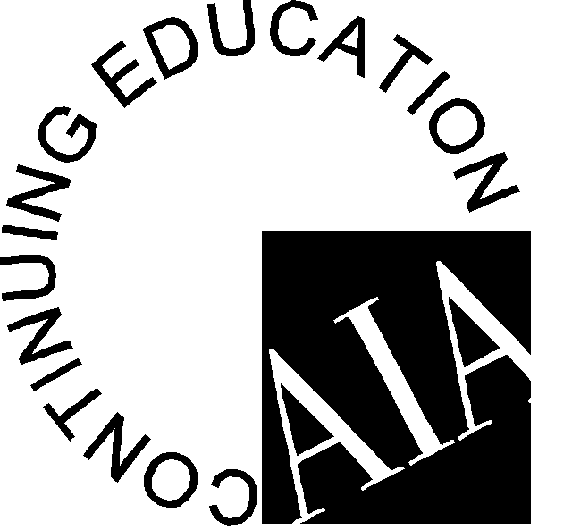

Participant Name:
AIA Member #: ________________________________
Request Certificate: Yes_____ No_____

Provider Name: Association for Learning Environments

Conference Number: 2022 SC Conference

Provider Number: F118 Program Dates: March 23-25, 2022 Program Location: Spartanburg, SC

Attended | Session # | Program Title | Credits | LU | LU/  HSW
March 24, 2022 – Keynote – 8:30 AM – 9:45 AM

Yes No | SC2201 | Alan Mallory – Reaching New Heights | 1 | Yes
March 7, 2022 – Sessions 1 – 10:00 AM - Choose 1

Yes No | SC2202 | Lessons Learned: How Flexible Spaces Provided Educational Success During a Pandemic | 1 | Yes
Yes No | SC2203 | Culture in Team Performance During Changing Times | 1 | Yes
Yes No | SC2204 | The Learning Playground: Adaptable Design Strategies for Equitable Access to Restorative Learning Environments | 1 |  | Yes
March 24, 2022 – Sessions II – 11:00 AM – Choose 1

Yes No | VASE2218 | Trauma Informed Microenvironments | 1 |  | Yes
Yes No | SC2205 | “If These Walls Could Talk...” | 1 | Yes
Yes No | VASE2219 | The Collision of AGILE and MESSY: Supporting the Requirements of Authentic Learning | 1 | Yes
March 24, 2022 – School Tours – 1:30 PM – 4:00 PM - Choose 1

Yes No | SC202009 | Tour 1: Spartanburg High School & Boiling Springs High School | 3 |  | Yes
Yes No | SC202010 | Tour 2: Fairforest Middle School & Drayton Elementary School | 3 |  | Yes
March 25, 2022 – Panel Discussion – 8:30 AM – 9:45 AM

Yes No | SC2208 | Emerging in the Hub City – Understanding the Changing Needs of Education | 1.25 |  | Yes
March 25, 2022 – Sessions III – 10:00 AM – Choose 1

Yes No | VASE2205 | Do You Really Know Your Buildings? | 1 |  | Yes
Yes No | 2021NC-03 | Net-Positive Education: The Pathway for a High-Performance Learning Environment | 1 |  | Yes
I hereby certify that the above information is true and accurate to the best of my knowledge and that I have complied with the AIA Continuing Education Guidelines for the reported activities.

ATTENDEE SIGNATURE (Credit will not be awarded without signature.) DATE

Participants: Complete and return this form to: The registration desk, or send to:

Attn.: Edi Francesconi – A4LE – 11445 E Via Linda, Suite 2-440 – Scottsdale, AZ 85259 – E-mail: edi@a4le.org

