Bringing IT ALL TOGETHER in Raleigh, NC for the A/E/C Industry on December 5th
GreenNC is a one-day event, hosted by the USGBC North Carolina Chapter, to provide education, information and networking to North Carolina and neighboring citizens interested in green building and sustainability. By bringing architects, engineers, contractors and consultants together with owners occupants and educators, the richness of the conversations and presentations have been notably valuable to attendees over the last seven years.
Located at the LEED Silver Raleigh Convention Center, our event will focus on green building leadership in publicly funded agencies, specifically the two sectors of local governments and education. Come learn, network and re-charge with 150+ like-minded professionals.
Event tickets start at $90.00.
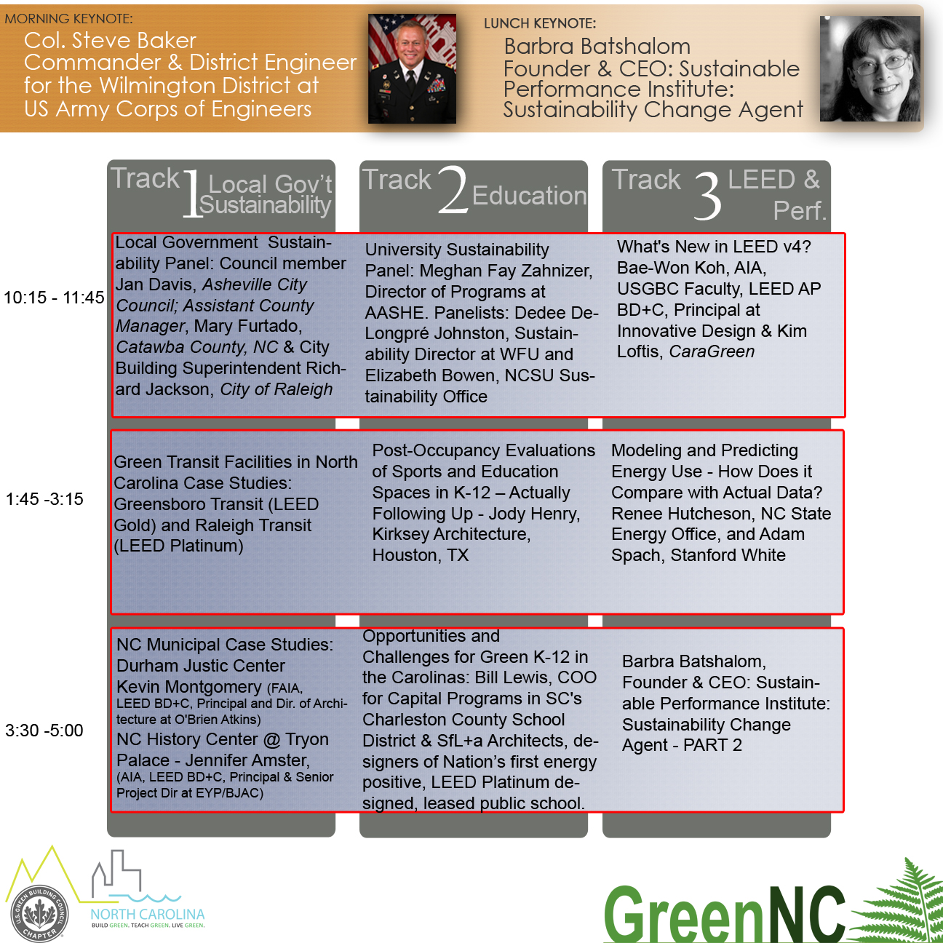

Register Now

