2019 AIA/CES Conference Session Participation Form (C-1)  - Sessions listed on this form have been registered with the AIA/CES Records. Attendance will be recorded on your behalf by the CES Registered Provider. You may request a copy of this form for your files.  - You must include your AIA membership number to get credit. Check Yes for those activities you have completed.  - Member numbers that are missing or not legible will not be awarded credit.  - Partial credit/concurrent sessions marked “attended” are not awarded. Attendance is subject to verification.  - DO NOT SEND THIS FORM DIRECTLY TO CES RECORDS — RETURN TO CONFERENCE STAFF!  - Conference Provider will verify your attendance before forwarding this form to CES Records to record credit. | 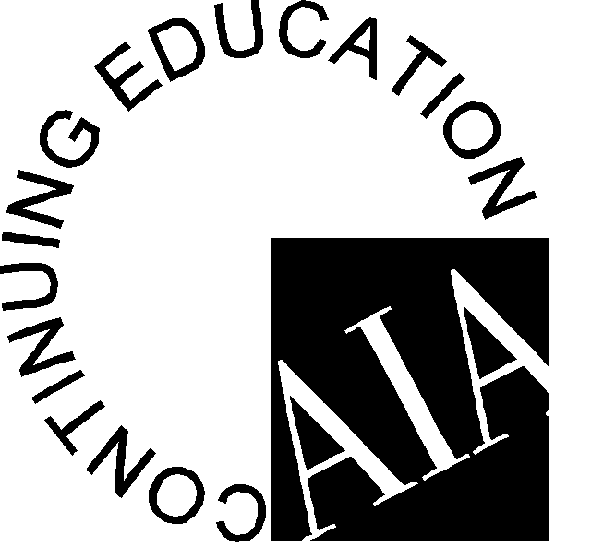

Participant Name:
AIA Member #: ________________________________
Request Certificate: Yes_____ No_____

Provider Name: Association for Learning Environments

Conference Number: 2019 North Carolina Chapter Conference

Provider Number: F118 Program Dates: March 31-April 02, 2019 Program Location: Winston-Salem, NC

Attended | Session # | Program Title | Credits | LU | LU/  HSW
April 1, 2019 – Sessions 1 – 10:45 AM – 11:45 AM – Choose 1

Yes No | NC19-01 | Think Better: Attention in Education – How Can Neuroscience Research Help Us optimize Student Success? | 1 |  | Yes
Yes No | NC19-02 | Best Design Practices for School Security | 1 |  | Yes
April 1, 2019 – SchoolsNEXT– 1:00 PM – 2:00 PM

Yes No | NC19-03 | NC SchoolsNEXT Presentation | 1 |  | Yes
April 1, 2019 – Sessions 2 – 2:15 PM – 3:15 PM – Choose 1

Yes No | NC19-04 | Yes, You Can Have it Too! Case Studies for STEM Upgrades in Existing Schools | 1 | Yes
Yes No | NC19-05 | 21st Century School Site Planning | 1 | Yes
April 1, 2019 – Sessions 3 – 3:30 PM – 4:30 PM – Choose 1

Yes No | NC19-07 | Optimizing Daylighting: Balancing Approach for Today’s Learning Environments | 1 |  | Yes
Yes No | NC19-10 | When Is Zero Energy the Right Choice? | 1 | Yes
April 2, 2019 – School Safety Panel – 09:00 AM – 10:30 AM

Yes No | NC19-08 | Panel Discussion on School Safety | 1.5 |  | Yes
April 2, 2019 – School Tour – 11:00 AM – 1:00 PM

Yes No | NC19-09 | Tour of the Downtown School | 2 |  | Yes
 |  | Total Hours Attended:
I hereby certify that the above information is true and accurate to the best of my knowledge and that I have complied with the AIA Continuing Education Guidelines for the reported activities.

ATTENDEE SIGNATURE (Credit will not be awarded without signature.) DATE

Participants: Complete and return this form to: The registration desk, or send to:

Attn.: Edi Francesconi – A4LE – 11445 E Via Linda, Suite 2-440 – Scottsdale, AZ 85259 – Tel. (480) 391-0840 –
E-mail: edi@a4le.org

