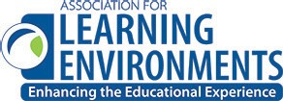

2022 WASHINGTON CONFERENCE POLISHED APPLE AWARDS
PHOTO RELEASE FORM
Please initial all that apply
Name of Project Location of Project Occupancy Date, if applicable

The Association for Learning Environments (A4LE) has our permission to:
Send photos electronically to jury members (required for entry).
Display photos in the award winners’ area of the website, if selected as a finalist.
Display photos on other sections of the website as representative A4LE projects.
Print photos in A4LE newsletters.
Print photos on A4LE marketing materials, i.e. brochures, awards, call for entries, etc.
Print photos and project details in the A4LE Design Portfolio, if selected as a finalist.
Special projects with prior permission.
Please Note: A4LE maintains an in-house archive of school designs as part of our research library. Your information will be entered and recorded as one of those designs.

Firm Responsible Party/Photographer Signature Date of Release

